**Measurement of Reflection coefficients and validating Fresnel’s Laws of Reflection**

**MSc Lab Short Experiments**



**Submitted By,**

Sujoy Karmakar, DAA, [*sujoy.karmakar@tifr.res.in*](sujoy.karmakar@tifr.res.in)

 Reyhan Beheram Mehta, DNAP, [*reyhan.mehta@tifr.res.in*](reyhan.mehta@tifr.res.in)

Rohit Shekhawat, DNAP, [*rohit.shekhawat@tifr.res.in*](rohit.shekhawat@tifr.res.in)

**Under the supervision of,**

Prof. S. S. Prabhu

**Experiment Date,**

September 24, 2024

* **Introduction:** Reflection, a fundamental phenomenon of light, occurs when an electromagnetic wave encounters a boundary between two media, causing a portion of the wave to bounce back. In the 19th century, Augustin-Jean Fresnel formulated laws, based on wave theory of light, that describe how the intensity and polarization of reflected and transmitted light depend on the incident angle and refractive indices of the media. Later Maxwell, with his Electromagnetic Theory, gave much deeper explanation about Fresnel’s laws. In this experiment we will try to measure the reflection coefficients at various incident angles for the p – polarised and s-polarised lights incident on a glass prism and validate the laws of reflections.
* **Theory and Working Principle:** Light is a

Reflected ray

Incident ray

Prism

transverse electromagnetic wave which is

constituent of oscillating electric and magnetic

fields in mutually perpendicular directions and

perpendicular to direction of propagation. When

the light is incident on the interface between 2

mediums, a part of it gets reflected back in the

initial medium, other part gets refracted in the

second medium. The reflection coefficients for

s-polarized (Plane of vibration of electric field is

perpendicular to the plane of incidence) and

p-polarized (Plane of vibration is parallel to plane

of incidence) are different. They are given by the

relations below. For s-polarized, i.e. perpendicular polarization, the amplitude reflection coefficient is,

---------------------------------(1)

For p-polarized, i.e. parallel polarization, the amplitude reflection coefficient is,

---------------------------------(2)

Where is the angle of incidence on the prism surface.

Now in the experiment, we measure current flow through the sensor circuit due to incidence of light on the sensor. So, then the coefficients will be,

-----------------------(3)

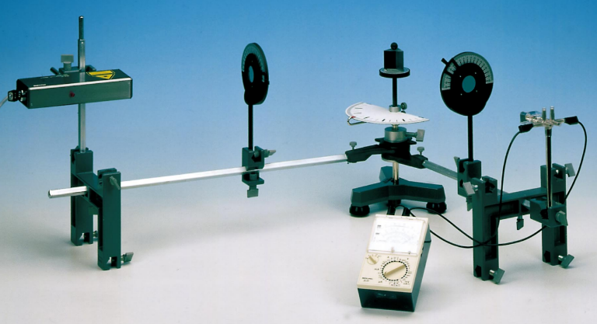

**Image Source: Experiment Manual**

-----------------------(4)

Where the is the current flow at angle of

incidence for perpendicular polarization,

is current value for incident ray in perpendicular

polarization and so on.

Now if initially the incident light was linearly polarized

with an angle 450 w.r.t the plane of incidence, then the change in angle of polarization (magnitude) with the change in the angle of incidence will be,

---------------------------(5)

* **Tasks:** Here in this experiment, we are goanna do,
  + Find the reflection coefficients for different incident angles for both parallel and perpendicular polarized light and plot them alongside with theoretical plot.
  + Find the rotation of the angle of polarization with change in incident angle for 450  polarized incident ray.
  + Plot the above alongside with theoretical plot.
* **Apparatus**: The apparatus used for this experiment are,
  + Laser source.
  + Polarizers.
  + Prism.
  + Experimental frame setup.
  + Photosensor.
  + Multimeter.
  + Power supply.
* **Experimental Data and Result:**

Here all the data are processed in python. The data file and code can be accessed by clicking on the link,

<https://github.com/Sujoy7471/Expt.Methods/tree/main/Frensel%20Laws%20of%20Reflection>

* + **Table 1:** Table to obtain

Here photocurrent for incident ray is 39.4 mA with background value 3.0 mA.

So,  **= 36.4 mA**

|  |  |  |  |  |
| --- | --- | --- | --- | --- |
| **(degree)** | **(mA)**  **(Current flow with reflected and background light)** | **(mA)**  **(current flow due to background light)** | **(mA)** |  |
| 20 | 3 | 1.4 | 1.6 | 0.2097 |
| 25 | 3.4 | 1.5 | 1.9 | 0.2285 |
| 30 | 3.6 | 1.7 | 1.9 | 0.2285 |
| 40 | 4.3 | 1.9 | 2.4 | 0.2568 |
| 45 | 4.8 | 1.8 | 3 | 0.2871 |
| 50 | 5.8 | 1.7 | 4.1 | 0.3356 |
| 55 | 9.9 | 2.2 | 7.7 | 0.4599 |
| 60 | 9.1 | 2.3 | 6.8 | 0.4322 |
| 65 | 12.1 | 2.5 | 9.6 | 0.5136 |
| 70 | 13.4 | 3 | 10.4 | 0.5345 |
| 75 | 18.3 | 2.8 | 15.5 | 0.6526 |
| 80 | 25.9 | 2.7 | 23.2 | 0.7983 |
| 85 | 34.4 | 3 | 31.4 | 0.9288 |

* 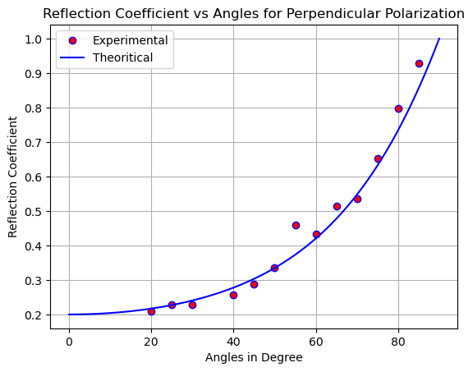**Output graph for Table 1:**
  + **Table 2:** Table to obtain

Here photocurrent for incident ray is 43.1 mA with background value 0.0 mA.

So,  **= 43.1 mA**

|  |  |  |  |  |
| --- | --- | --- | --- | --- |
| **(degree)** | **(mA)**  **(Current flow with reflected and background light)** | **(mA)**  **(current flow due to background light)** | **(mA)** |  |
| 20 | 4.88 | 3.28 | 1.60 | 0.1927 |
| 25 | 3.96 | 2.81 | 1.15 | 0.1633 |
| 30 | 3.88 | 2.79 | 1.09 | 0.1590 |
| 40 | 2.99 | 2.41 | 0.58 | 0.1160 |
| 45 | 3.13 | 2.69 | 0.44 | 0.1010 |
| 50 | 3.24 | 3.01 | 0.23 | 0.0731 |
| 52.5 | 3.36 | 3.17 | 0.19 | 0.0664 |
| 55 | 3.13 | 2.96 | 0.17 | 0.0628 |
| 56 | 3.53 | 3.26 | 0.27 | 0.0791 |
| 57 | 3.45 | 3.16 | 0.29 | 0.0820 |
| 58 | 3.67 | 3.36 | 0.31 | 0.0848 |
| 59 | 4.4 | 3.83 | 0.57 | 0.1150 |
| 60 | 3.8 | 3.15 | 0.65 | 0.1228 |
| 62.5 | 5.6 | 4.5 | 1.10 | 0.1598 |
| 70 | 7 | 4.1 | 2.90 | 0.2594 |
| 75 | 10.2 | 5.6 | 4.60 | 0.3267 |
| 80 | 16.5 | 5.7 | 10.80 | 0.5006 |
| 85 | 28.2 | 7.2 | 21.00 | 0.6980 |

* + 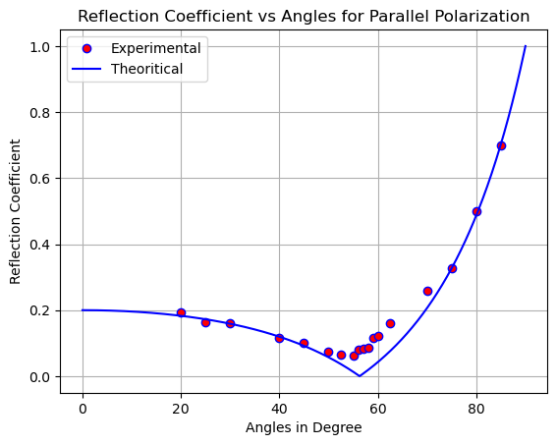**Output Graph for Table 2:**
  + **Table 3:** Table to find the rotation of the angle of polarization with change in incident angle for

450  polarized incident ray.

|  |  |  |  |
| --- | --- | --- | --- |
| **(degree)** |  |  | **(degree)** |
| 20 | 0.2097 | 0.1927 | 2.4191 |
| 25 | 0.2285 | 0.1633 | 9.4481 |
| 30 | 0.2285 | 0.159 | 10.1682 |
| 40 | 0.2568 | 0.116 | 20.6907 |
| 45 | 0.2871 | 0.101 | 25.6185 |
| 50 | 0.3356 | 0.0731 | 32.7119 |
| 55 | 0.4599 | 0.0628 | 37.2243 |
| 60 | 0.4322 | 0.1228 | 29.1387 |
| 70 | 0.5345 | 0.2594 | 19.1121 |
| 75 | 0.6526 | 0.3267 | 18.4069 |
| 80 | 0.7983 | 0.5006 | 12.9089 |
| 85 | 0.9288 | 0.698 | 8.0749 |

* + **Output Graph for Table 3:**

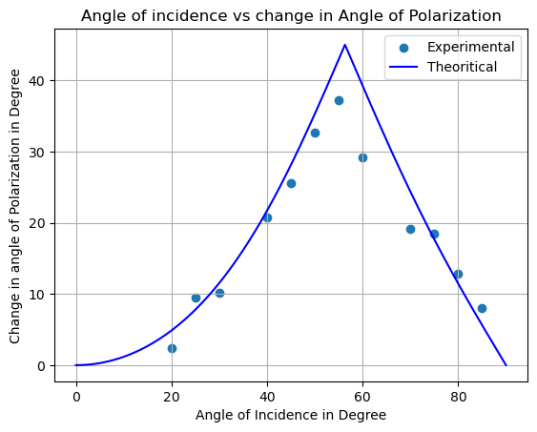

* **Comments:** After doing this practical and processing the data obtained, we can clearly see that they are in good agreement with the theoretical predictions. The deviation occurred due to the facts that no value can be measured with infinite precision, there is always errors due to human and apparatus.